**SQL ASSIGNMENT 2**

**Submitted by:** Navyatha Godla

**Submitted on**: 10/02/2024.

**Task:** 1. Create a user-defined function to stuff the Chicken into ‘Quick Bites’.Eg: ‘Quick Chicken Bites’

**Code:**

Create function udf_StuffintoQuickBites(@word Nvarchar(100))

returns nvarchar(100)

as begin

declare @new_word nvarchar(100);

set @new_word = 'Quick ' + @word +' Bites';

return @new_word;

end;

Select dbo.udf_StuffintoQuickBites('Chicken')

**Task:** 2. Use the function to display the restaurant name and cuisine type which has the maximum number of rating.

**Code:**

Create function udf_Resturant_MaxNo_Raiting( @Restaurant_type varchar(100))

returns table

as return

(select Top 1

J.RestaurantName, J.CuisinesType

from Jomato as J

where J.RestaurantType=@Restaurant_type

order by J.No_of_Rating desc);

Select * from dbo.udf_Resturant_MaxNo_Raiting('pub');

**Result:**

**Task:** 3. Create a Rating Status column to display the rating as ‘Excellent’ if it has more the 4 start rating, ‘Good’ if it has above 3.5 and below 4 star rating, ‘Average’ if it is above 3 and below 3.5 and ‘Bad’ if it is below 3 star rating and

**Code:**

Alter table Jomato add Rating_status varchar(50);

update Jomato set Rating_status =

case

when Rating > 4 then 'Excellent'

when Rating > 3.5 AND Rating <= 4 then 'Good'

when Rating > 3 AND Rating <= 3.5 then 'Average'

when Rating <= 3 then 'Bad'

else 'Unknown'

end;

Select * from Jomato

**Result:**

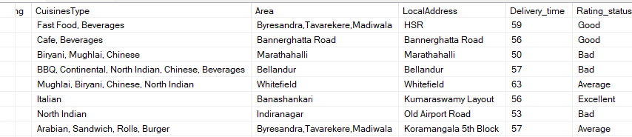

**Task:** 4. Find the Ceil, floor and absolute values of the rating column and display the current date and separately display the year, month_name and day.

**Code:**

Select

CEILING(Rating) as Rating_Ceiling, FLOOR(Rating) as Rating_Floor,

ABS(Rating) as Rating_Absolute, convert(date,GETDATE()) as CurrentDate,

Year(Getdate()) as Year, Datename(Month,getdate()) as Month, Day(getdate()) as Day

from Jomato

**Result:**

**Task:** 5.Display the restaurant type and total average cost using rollup.

**Code:**

Select RestaurantType,

Avg(AverageCost) as [Total Average Cost]

from Jomato

group by RestaurantType with rollup;

**Result:**

